Exposure Anxiety. Don’t look at me!

Does your child get you to turn the door handle or pick his toys up? Do you sometimes catch him doing things or perhaps even hear him talking or singing to himself when he thinks he’s alone? Does he avoid using personal pronouns? Or is his speech nonexistent or limited to a few “safe” words or phrases?

If so it is possible that he suffers from Exposure Anxiety (EA); a condition which was identified by Donna Williams in her book Exposure Anxiety—The Invisible Cage. Although the roots of this problem are complex it is similar but far more severe than social anxiety disorder.

EA can be quite crippling as it causes the person to feel acutely self-conscious and leads to a persistent and overwhelming fear of interaction.

That makes any attention from other people feel potentially threatening so that the child feels “exposed” each time someone looks at him, talks to him or even compliments him.

Most children cope with this by attempting to “block out” the triggers. That can lead to some strange reactions as he may ignore the people he likes most or respond to direct praise by losing interest or disowning (or even destroying) his
achievements.

The concept of exposure anxiety challenges many common assumptions such as:
- The child is rejecting – for although his actions may indicate that, they do not necessarily relate to his real feelings.
- Stereotyped behaviors should be discouraged – which misses the fact that such behaviors can often be positive – acting as a gateway to learning, a reward, or even a pressure valve which helps the child unwind when he is particularly stressed.
- Bad behavior should be ignored, and good behavior should be praised for, while this works for many children, it is counter-productive for children who cannot cope with direct attention.

NOTE
Sometimes such a child will make contact with you or do something positive only for the EA to make them “punish” themselves in some way; perhaps by:
- breaking or throwing things
- self-abusive behaviours
- stopping eating.

How can you help?
The best way is to approach things INDIRECTLY so that you avoid triggering the child’s anxiety. Some of the following ideas seem a little strange to start with but even so they can prove extremely effective with some children:

Top tips
Using INDIRECT COMMUNICATION – examples below.
- There are times when he wants to do something but is unable to ask. If so, try asking him to do things for another person. Thus, if you think he needs the toilet, suggest he takes a sibling there, as once there he may use the toilet himself.
- If you wish to discuss a particular situation, try talking about it quietly to yourself when you know he can hear. Alternatively, take advantage of his super-sensitive hearing by talking to someone else about it or by talking to a non-existent person on the phone.
- If mealtimes are difficult use a similar approach, suggesting (to someone else) that he should eat separately until he can cope. (If he then joins you at the table, don’t comment – and don’t expect it to happen every time).
- Don’t praise or comment on his achievements directly as he may abandon or destroy them. If you want to reward him, comment indirectly, praising the items he used rather than him, for example, “those crayons d r e w that picture well”, or alternatively use a star/sticker system which focuses on the achievement rather than on him.
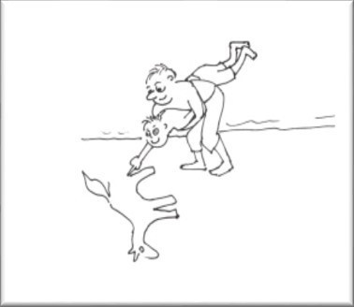
- If he gets you to do things for him start by doing things for him and then remove your support gradually so that he has to do something himself to complete the action like fetching the biscuit tin for him but only partially opening the lid before you go to do something else.
- Swap roles, for example, when painting or playing an instrument so that you use his hand to make a picture in the sand, bang a drum, etc.
- Model things by using them while he is in the room – but don’t show him how to use them directly as he might reject them altogether.
- Introduce new toys or equipment by leaving them in his room or around the house for him to find but do remember to ignore him if/when he begins to show an interest or use them.

NOTE
Some children perceive Exposure anxiety as an external “controller” who directs their actions.
- If he begins to throw or break things try focusing your attention on him and say something like …. “in a minute he is going to …. (throw a chair etc)”.
- Allow him to eat on his own if necessary as that may relieve the pressure from his EA.

