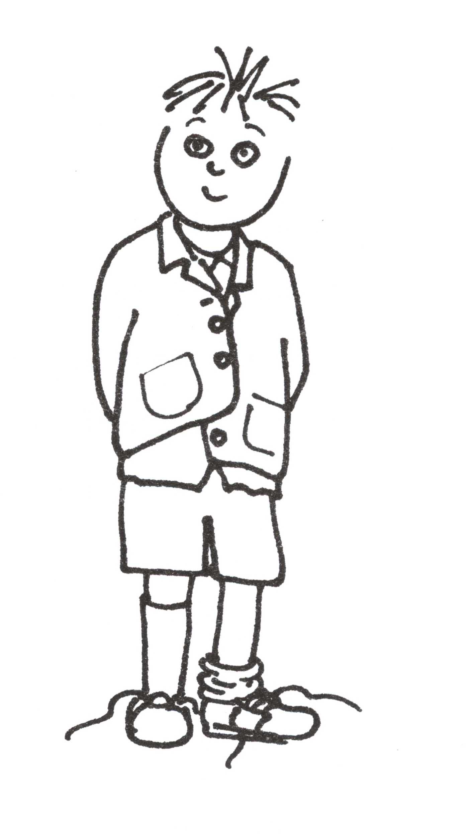
DYSPRAXIA
PRAXIS IN PRACTICE
Stella Waterhouse

Praxis is the link between our brains and our behaviour that allows us to make choices, plan our lives and our actions which enables us to dress ourselves, eat, play, write, work etc.
Unlike our reflexes, the movements involved in praxis are actually voluntary ‘skilled’ movements that are under our control. Although, as adults, we tend to take them for-granted the infant puts in many hours of practice as he crawls around and tries to pull himself upright or repeatedly reaches for and grasps an object that he wants to explore.
Most of us have no recollection of the time we once spent practicing such skills and may find it hard to imagine how awful it would be if every movement you wanted to make still needed conscious thought and effort. And how immensely tiring it would be.
Perhaps though you can think back to the time you last learnt a complicated skill like driving. Remember the problems you had initially when trying to learn to pull out into traffic or reverse into a small space? When you had to learn to look in the mirror whilst also trying to coordinate your hands and feet in a particular sequence – and listen to the instructor? If you have been driving for any length of time you will now (hopefully) do these things automatically – at least until you start thinking about them. Just like the millipede who fell in a ditch when asked which foot he started with – everything works okay until you think about it!
Play enables the child to experiment with a wide range of activities and explore new areas. Besides helping him develop self-confidence and a positive self-image it allows him to learn and practice a variety of skills e.g. gross motor; co-ordination and social skills e.g. turn taking, giving and sharing. This is vital if he is to learn about and understand the world around him and form the basic concepts, e.g.: under/over, up/down - which will help him when he starts school.
Unfortunately, the problems posed by dyspraxia (e.g. limited or impaired movement) diminish his enjoyment of play and exploration. This, in turn, limits his activity and becomes a vicious circle that interferes with his intellectual and social skills. In the long term this can affect his emotional development and erode his self-confidence.
Such problems also affect his daily life in other ways. Even such an apparently simple thing as sitting and eating a meal at a table involves a combination of skills. These include good balance (for sitting) while good shoulder control, hand-eye co-ordination, body awareness and the ability to use the tongue/mouth correctly are all needed in order to use the cutlery, place it in the mouth, chew and swallow.
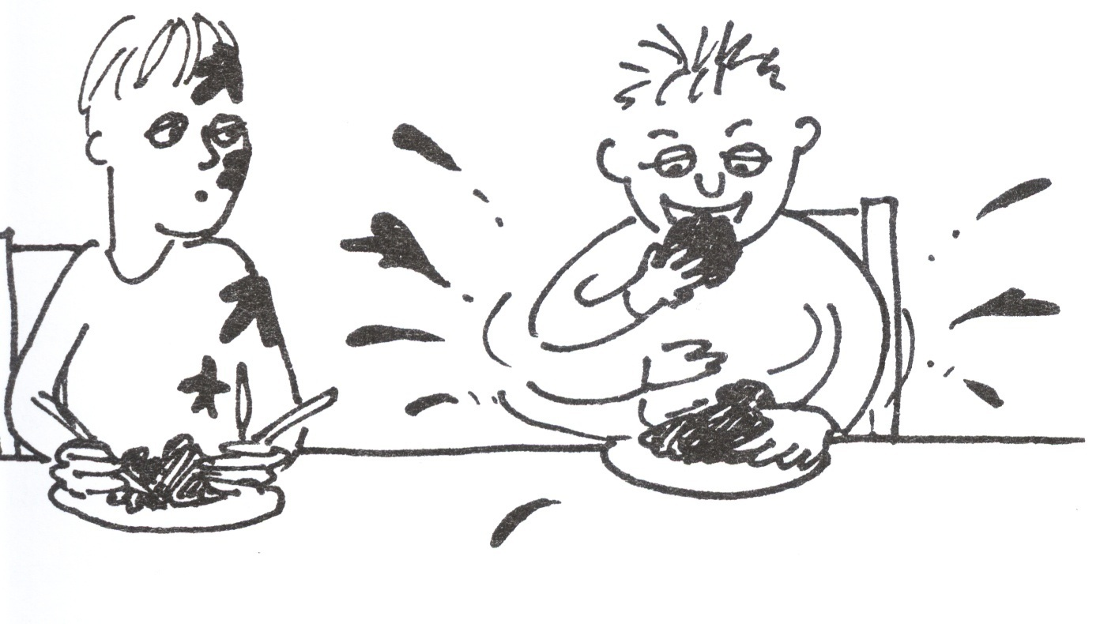

Similarly when the child begins school he will need to be able to use a wide range of skills to enable him to write or do PE, which, in addition to the skills mentioned above, includes directional and spatial awareness as well as the ability to plan his movements and short-term memory.

Excerpt taken from Whoops! A Teacher's Guide to Dyspraxia – currently available on Amazon Kindle.

For more information about dyspraxia see: www.sensorydifferences.com

