Autism and Face Blindness – Who Are You?
March 13, 2015 by Stella Waterhouse
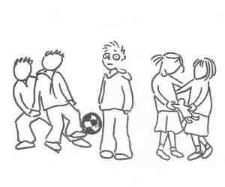
At some point in our lives most of us have met someone we cannot quite place. We ‘know‘ we know them but don’t recognize them immediately because they are out of context: perhaps no longer wearing a uniform or in the place where we would usually see them. An embarrassing situation but one that happens to most of us only occasionally.
But how would you feel if it happened to you constantly? If you recognized your parents at home but inadvertently walked past them in the street? That is the world that people with face-blindness live in each and every day of their lives. When severe it can result in an avoidance of social interactions, problems with relationships, anxiety and even depression.
That is also a world in which some people with ASD live as we can see from their accounts.
Thus in her book A Real Person – Life on the Outside Gunilla Gerland, who has Asperger’s syndrome, described seeing children with blank faces. Nor is she alone in that for Donna Williams tells us how ‘complete strangers‘ used to smile or wave at her, some even calling her by name. Others too describe seeing only parts of a person such as a bald head, beard or earring; which may explain why some children focus on and are seemingly fascinated by such details.
School can be particularly stressful for any child who is face-blind.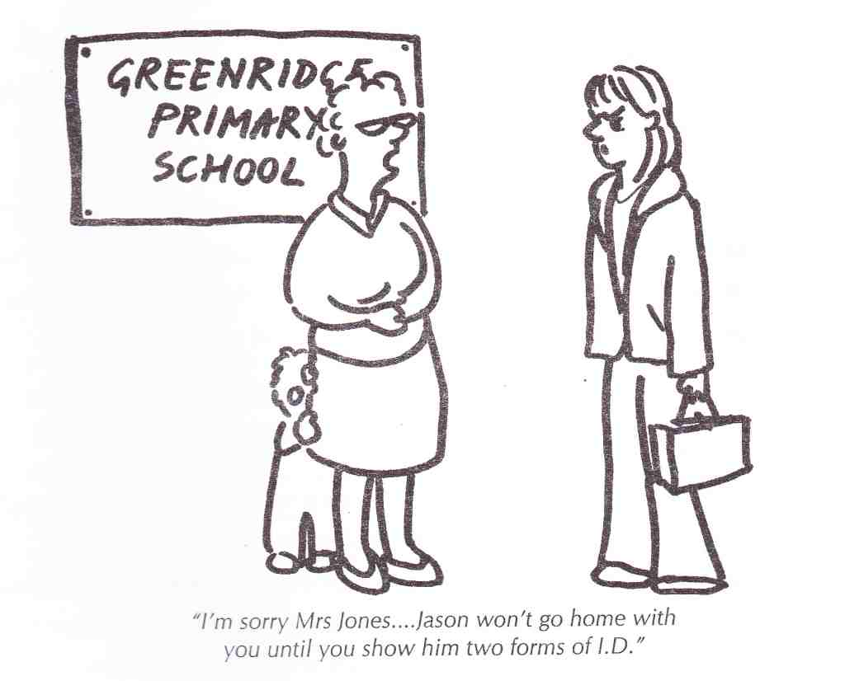
He will not be able to identify other pupils (even after sitting beside them for some time), may confuse one person with another and could find the playground frightening. He could also have difficulty ‘reading‘ facial expressions or body language correctly – which will make it very hard to distinguish friend from foe. Sadly his problems are often compounded by the fact that other children see him as arrogant or aloof because they mistakenly believe that he ignores them outside school – and that may make him a target for bullying.
Hardly surprising then that many such children learn to use other clues to identify people – like the way they smell, their clothes, the way they move or an identifying feature such as a mole, tattoo, beard and so forth.
~~~
Useful tips to help the child who is faceblind:
* Explain face-blindness to him and to those who are in daily contact with him such as teachers/other staff.
* Ask the school staff to wear badges/lapel pins and to introduce themselves by name when speaking to him.
* If possible ask if he can have a class seating plan (with photos).
* A school without uniforms will make life easier.
* Always introduce people to him by name even if he already knows them.
* Suggest ways in which he can identify people – using the features which are least likely to change:
Voices/accents.
People’s body shapes, posture, the way they stand, their gait – or the way their clothes move as they walk.
Clothes – as people often wear distinctive styles.
Hats/coats/shoes – as people generally have only a few favorites.
* If you or someone he knows well alters something significant like a hairstyle tell him in advance if possible.
* If you do not have any identifiable marks wear a particular brooch/tiepin/ lapel badge – especially when picking him up from school.
* Teach him to say ‘I’m sorry, I don’t know who you are’ if necessary.
~~~
Face-blindness (also known as prosopagnosia) used to be considered extremely rare but is now known to affect around one person in 50 to some degree. While it can be acquired through some type of brain injury, some children have what is termed congenital or developmental prosopagnosia, with the child being affected from birth.
Developmental prosopagnosia can run in families and is said to be particularly common among people with ASD. It has been suggested that this is because the visual perception pathways have either been damaged or have not fully developed. Perhaps in time research will be able to determine whether there are other causes too.
Editor’s Note: The male pronoun is used to cover references to both the male and female. No gender preference is intended.

